



|  |  |
| --- | --- |
| Name | Akshat amla |
| Roll no. | 2021a1r064 |
| branch | c.s.e |
| Course name | Operating systems lab |
| Course code | Com-312 |

EXPERIMENT – 1:

Practice basic bash, IO redirection, pipe, file and directory operations, searching files, process management and vi/nano editor commands.

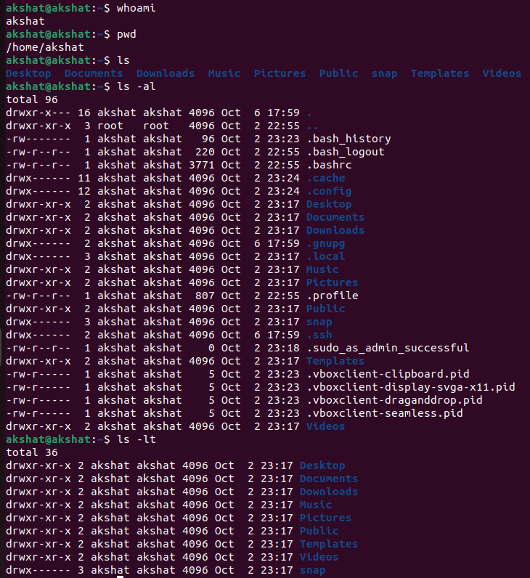

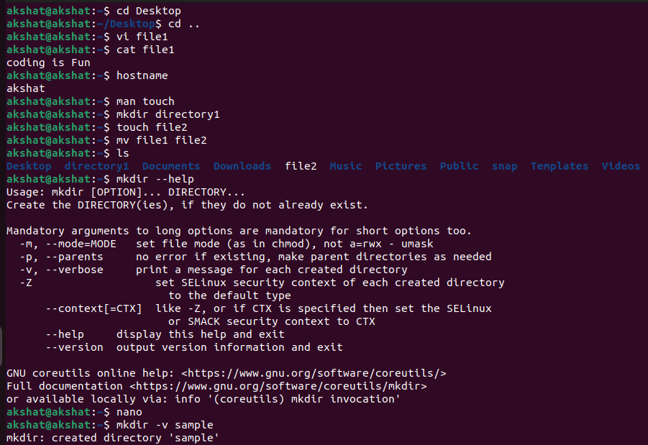 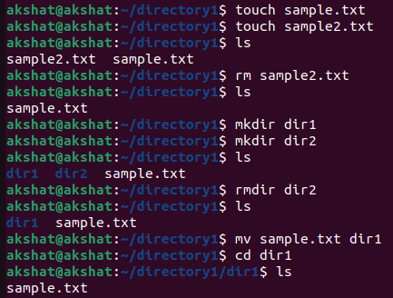

EXPERIMENT – 2:

* Use the date and who commands, in one line, such that the output of date is displayed on the screen and the output of who is redirected to a file.
* Write a sed command that swaps the first and second words in each line in a file.

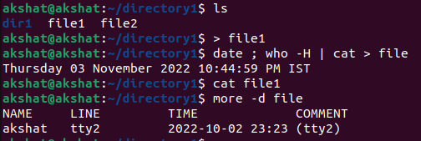

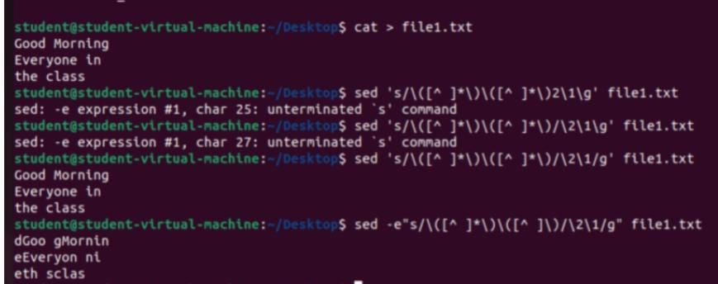

EXPERIMENT – 3:

* Write a shell script that takes a command line argument and reports on whether it is a directory or a file.
* Write a shell script that takes file names as arguments and convert all of them to uppercase.

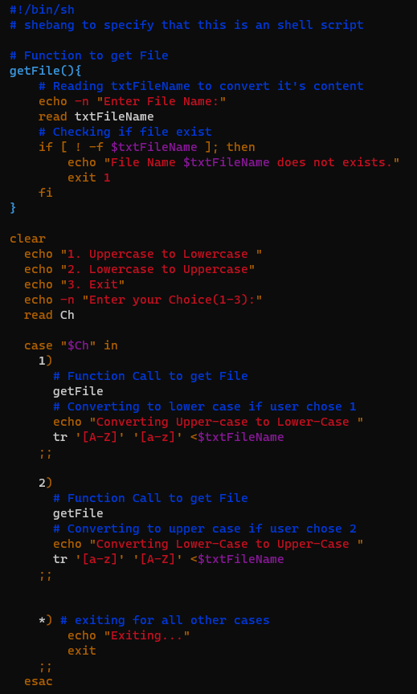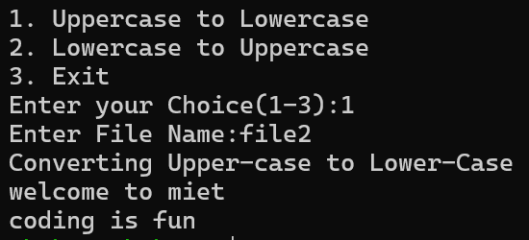 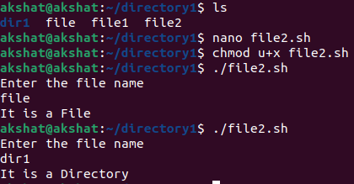

EXPERIMENT – 4:

Write a shell script and C program to perform the following string operations:

* To extract a substring from a given string.
* To find the length of a given string.

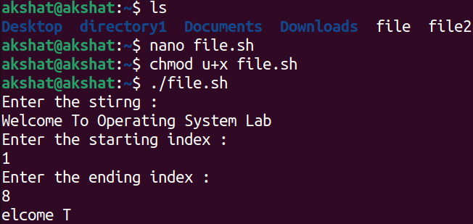

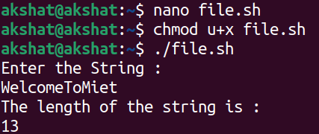

EXPERIMENT – 5:

Write a C program that takes, as a command line argument, the number of megabytes of memory it will use and during execution it should consume that much memory. Observe memory usage during program execution using free command.

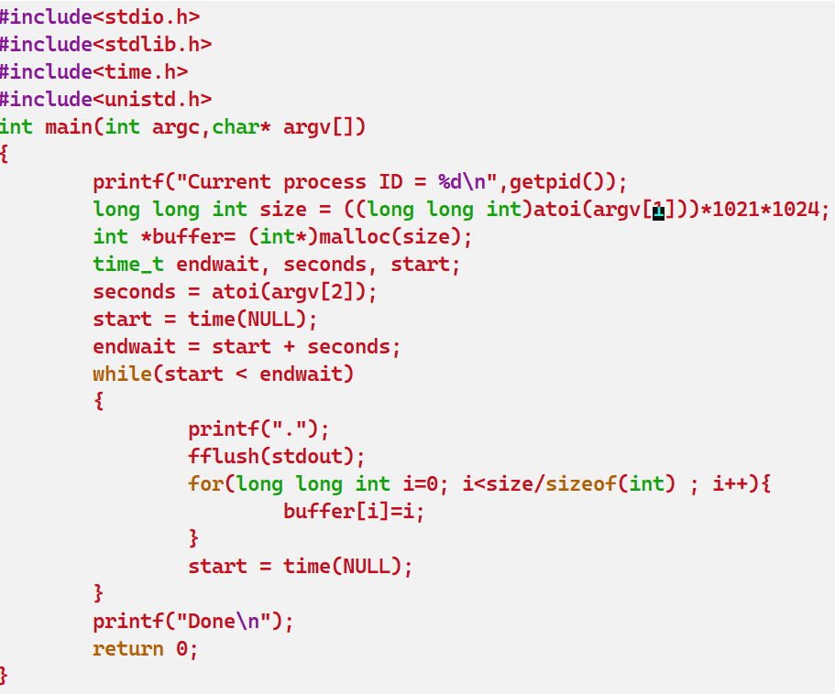

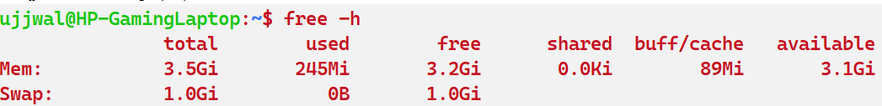

EXPERIMENT – 6:

Write a CPU bound C program and a I/O bound C program and observe the effect of their CPU share using the top command and its variants.

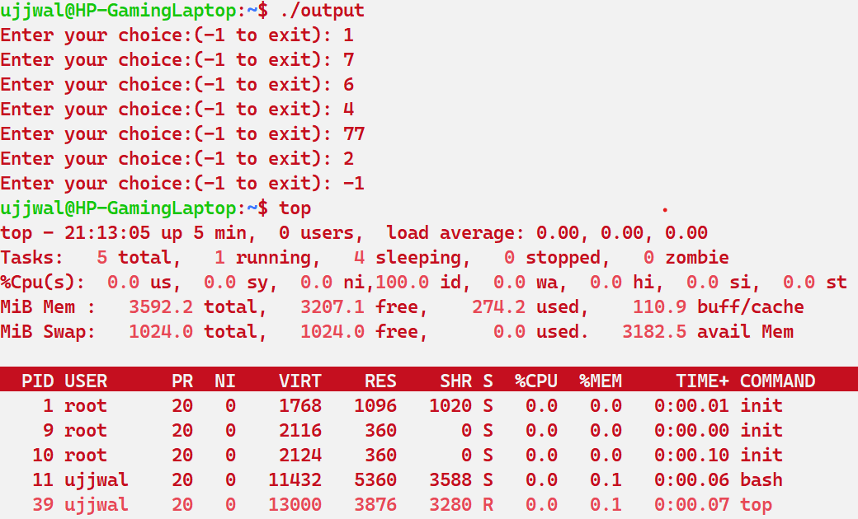

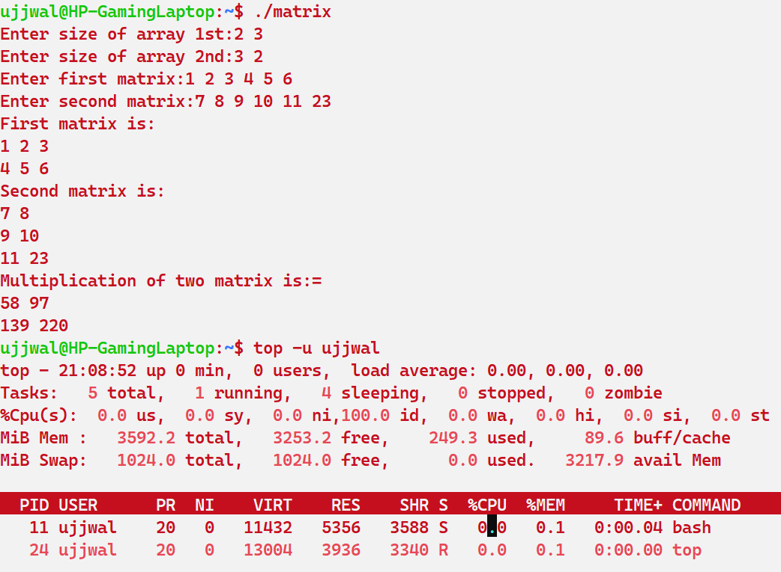

EXPERIMENT – 7:

Observe and understand the process map of the previous two lab programs using pmap command.

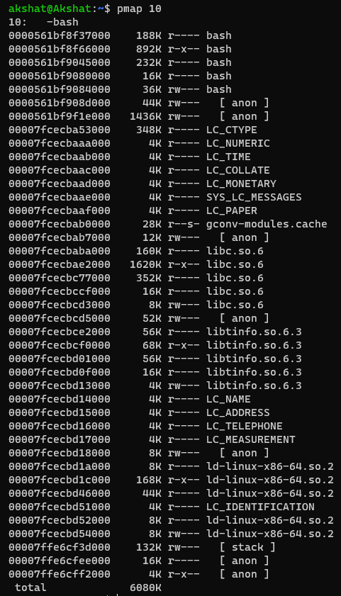

EXPERIMENT – 8:

Write a program in C that creates a child process, waits for the termination of the child and lists its PID.

